Powys Community Health Council are looking for Volunteers

Do you have 3—5 days free per month ?

Do you have an interest in helping your local community to improve the services that are provided by the NHS ?

We are looking for volunteers from all walks of life — to help us improve the NHS locally and nationally. Community Health Council members are local volunteers who act as the eyes and ears of patients and the public; listening to their concerns and working with the health service to improve the quality of patient care, letting those in charge of health services know what people want and how things can be improved.

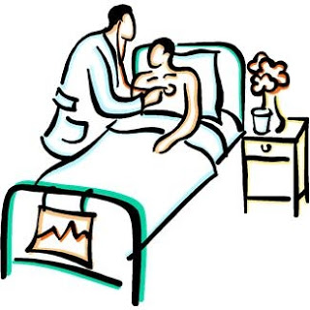

Everyone who uses health services has something to contribute.

If you are interested in becoming a volunteer please contact our Business Manager Kirsten.jones@waleschc.org.uk or you can contact us by telephone on 01874 624206

